It seems like you've listed several Python libraries that are commonly used in data analysis, statistics, and visualization. Here's a brief overview of each:

**1.Pandas**

Purpose: Pandas is a powerful data manipulation and analysis library.

It provides data structures like DataFrames and Series, making it easy to handle and analyze structured data.

**Key Features:** Data cleaning, merging, grouping, filtering, and handling missing data.

**2. NumPy:**

Purpose: NumPy is a fundamental package for scientific computing in Python. It provides support for large, multi-dimensional arrays and matrices, along with mathematical functions to operate on these arrays.

**Key Features**: Array operations, linear algebra, mathematical functions.

**3. Matplotlib and Seaborn:**

**Matplotlib:**

**Purpose:** Matplotlib is a comprehensive 2D plotting library. It enables the creation of static, animated, and interactive visualizations in Python.

**Key Features**: Line plots, scatter plots, bar plots, histograms, etc.

**Seaborn:**

**Purpose:** Seaborn is built on top of Matplotlib and provides a high-level interface for drawing attractive statistical graphics.

**Key Features:** Statistical data visualization, aesthetically pleasing plots.

**4. SciPy:**

**Purpose**: SciPy is an open-source library for mathematics, science, and engineering. It builds on NumPy and provides additional functionality for optimization, signal processing, statistics, and more.

**Key Features:** Integration, optimization, signal and image processing, statistical functions.

**5. Statsmodels:**

**Purpose**: Statsmodels is a library for estimating and testing statistical models. It includes various statistical models and tests for hypothesis testing, regression analysis, and time-series analysis.

**Key Features:** Regression models, time-series analysis, hypothesis testing.

**6. Statistics:**

**Purpose:** The built-in `statistics` module in Python provides functions for basic statistical operations. It includes mean, median, mode, variance, standard deviation, and more.

**Key Features:** Basic statistical measures.

These libraries are often used together in data analysis and scientific computing projects, allowing users to handle, manipulate, analyze, and visualize data efficiently.

**Percentile:**

A percentile is a measure that tells you what percentage of the data falls below a certain value.

**Example using np.percentile:**

If you have a dataset (data) and you use np.percentile(data, [25]), it means you want to find the value below which 25% of the data falls.

The number inside the square brackets ([25]) is the desired percentile. In this case, it's 25%, but you can change it to find other percentiles.

In simpler terms, using np.percentile(data, [25]) helps you identify a value below which a specific percentage of your data is located.

**Q1, Q2, Q3, Q4 (Quartiles):**

These are values that divide a dataset into four equal parts.

Q1 is the 25th percentile, Q2 is the median (50th percentile), Q3 is the 75th percentile, and Q4 is the maximum value.

**IQR (Interquartile Range):**

- It's the range between the first quartile (Q1) and the third quartile (Q3).

- Calculated as IQR = Q3 - Q1.

**Lower and Upper Fences:**

- These are used to identify potential outliers.

- The lower fence is calculated as Q1 - (1.5 * IQR).

- The upper fence is calculated as Q3 + (1.5 * IQR).

So, in summary, you are calculating the Interquartile Range (IQR) and then defining lower and upper fences to identify values that might be considered outliers in your dataset. Values outside these fences may be flagged as potential outliers.

It looks like you've created a list `data_copy` and are now using the Seaborn library to create a boxplot. A boxplot is a graphical representation that displays the distribution of a dataset based on five summary statistics: minimum, first quartile (Q1), median (Q2), third quartile (Q3), and maximum. It can also help identify potential outliers.

Here's a brief explanation of what your code is doing:

```python

data_copy = [12, 23, 24, 32, 32, 32, 43, 45, 45, 56, 67, 150]

import seaborn as sns

sns.boxplot(data_copy)

```

1. You've defined a list called `data_copy` containing numerical values.

2. You've imported the Seaborn library using `import seaborn as sns`.

3. You've created a boxplot using `sns.boxplot(data_copy)`. This command uses Seaborn's `boxplot` function to visualize the distribution of the data in `data_copy`.

- The box represents the interquartile range (IQR) between the first quartile (Q1) and the third quartile (Q3).

- The line inside the box represents the median (Q2).

- The "whiskers" extend to the minimum and maximum values within 1.5 times the IQR.

- Points beyond the whiskers may be considered as potential outliers.

By looking at the boxplot, you can get a visual summary of the distribution of your data, identify the central tendency, and observe any potential outliers.

The variance is a measure of how much a set of numbers deviate from their mean (average). The formula for calculating the variance of a sample is:

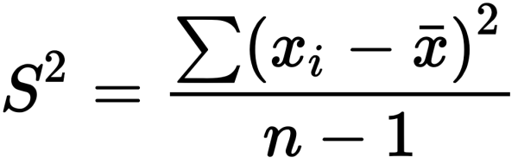

**Where**:

n is the number of observations in the sample.

xi​ is each individual observation in the sample.

xˉ is the mean of the sample.

If you are dealing with the entire population and have data for all members, you would use the population variance formula:

Population Variance (σ2)=∑(xi​−μ)2​/N

**Where:**

N is the number of observations in the population.

xi​ is each individual observation in the population.

μ is the mean of the population.

In both formulas, you calculate the squared difference between each data point and the mean, sum up these squared differences, and then divide by the number of observations (for sample variance, divide by n−1 to correct for bias). The result is the measure of variance.

**A Probability Density Function (PDF) :**

A Probability Density Function (PDF) is a statistical concept used to describe the likelihood of a continuous random variable falling within a particular range. In simple terms, it provides a way to understand the distribution of values for a continuous variable.

Here are the key points about Probability Density Functions:

**1. Continuous Variables:**

- PDFs are used for continuous random variables. These are variables that can take on any value within a range, as opposed to discrete variables that can only take specific, distinct values.

**2. Not Direct Probabilities:**

- Unlike probability mass functions (PMFs) used for discrete variables, a PDF doesn't give the probability of a specific value occurring. Instead, it gives the probability density over a range of values.

**3. Probability Density:**

- The probability density at a particular point on the continuous scale represents the likelihood of the variable taking a value near that point. The actual probability of an exact value is zero, but the density indicates how "crowded" the values are around that point.

**4. Area Under the Curve:**

- The integral (area under the curve) of the PDF over a specific range gives the probability that the variable falls within that range. In mathematical terms, the total area under the PDF curve is 1, representing the total probability of all possible outcomes.

**5. Peak Indicates Likelihood:**

- The highest point (peak) on the PDF curve indicates the most likely values for the variable.

6. **Examples**:

- If you have a PDF for the heights of people, the curve might be higher around the average height, indicating that heights close to the average are more likely.

**7. Normalization:**

- PDFs are often normalized so that the total area under the curve equals 1. This makes it a proper probability distribution.

**8. Mathematical Representation:**

- In mathematical terms, the PDF is often denoted by (f(x)), where (x) is the variable, and (f(x)) gives the probability density at (x).

In summary, a Probability Density Function is a tool in probability theory and statistics that helps us understand the distribution of continuous random variables, providing insights into the likelihood of different values within a range.

**standard deviation:**

The standard deviation ((sigma)) is a measure of the amount of variation or dispersion in a set of values. It is closely related to the variance (sigma^2), as the standard deviation is the square root of the variance. The standard deviation is often preferred in practice because it is expressed in the same units as the original data, making it more interpretable.

The formula for the standard deviation is as follows:

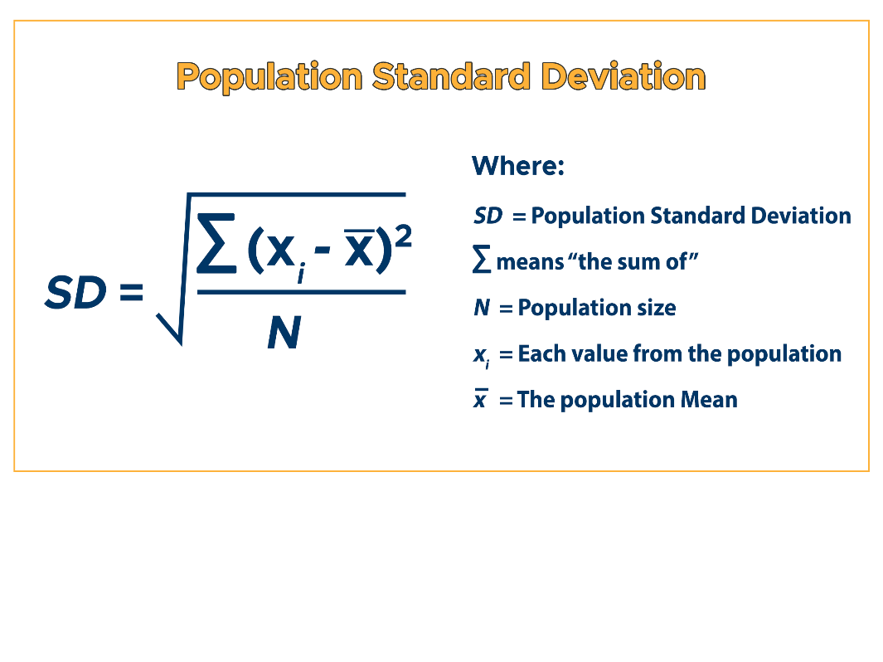

In other words, it is the square root of the variance.

The steps involved in calculating the standard deviation are similar to those for calculating the variance:

1. Find the mean ((mu) of the dataset.

2. Subtract the mean from each data point (xi).

3. Square the result of each subtraction.

4. Calculate the average of the squared differences.

5. Take the square root of the result obtained in step 4.

Mathematically, the standard deviation can be expressed at above image:

The standard deviation provides a measure of the spread of values in a dataset, and it is widely used in statistics to describe the variability within a set of data.